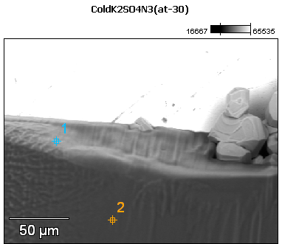

Image Name: ColdK2SO4N3(at-30)

Image Resolution: 512 by 384

Image Pixel Size: 0.45 µm

Acc. Voltage: 12.0 kV

Magnification: 550

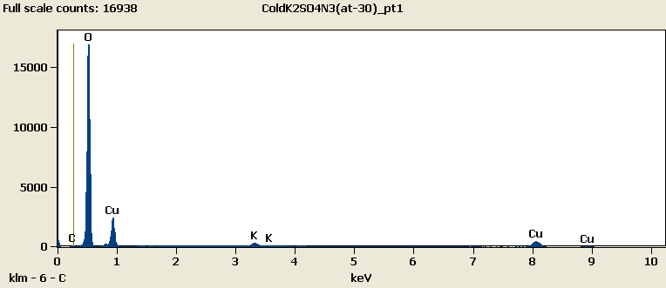

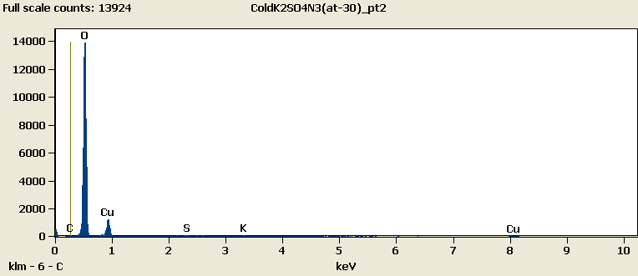

Weight %

|  |  |  |  |  |  |
| --- | --- | --- | --- | --- | --- |
|  | ***C-K*** | ***O-K*** | ***S-K*** | ***K-K*** | ***Cu-L*** |
| ***ColdK2SO4N3(at-30)_pt1*** | 0.51 | 66.62 |  | 2.34 | 30.53 |
| ***ColdK2SO4N3(at-30)_pt2*** | 0.08 | 73.47 | 0.23 | 0.45 | 25.78 |

Weight % Error (+/- 1 Sigma)

|  |  |  |  |  |  |
| --- | --- | --- | --- | --- | --- |
|  | ***C-K*** | ***O-K*** | ***S-K*** | ***K-K*** | ***Cu-L*** |
| ***ColdK2SO4N3(at-30)_pt1*** | ±0.10 | ±0.25 |  | ±0.16 | ±0.29 |
| ***ColdK2SO4N3(at-30)_pt2*** | ±0.11 | ±0.29 | ±0.06 | ±0.07 | ±0.33 |

# Cations

|  |  |  |  |  |  |
| --- | --- | --- | --- | --- | --- |
|  | ***C-K*** | ***O-K*** | ***S-K*** | ***K-K*** | ***Cu-L*** |
| ***ColdK2SO4N3(at-30)_pt1*** | 0.00 | 0.00 |  | 0.00 | 0.00 |
| ***ColdK2SO4N3(at-30)_pt2*** | 0.00 | 0.00 | 0.00 | 0.00 | 0.00 |